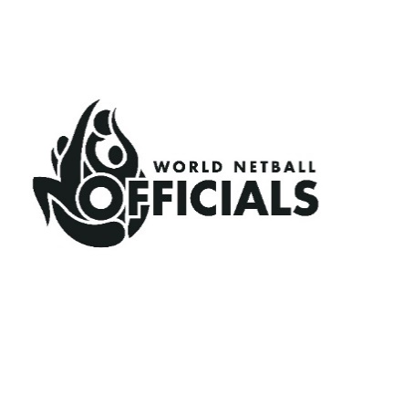
WORLD NETBALL
OFFICIATING COORDINATOR (OC)

Application form

Please use this form to apply for the OC role. Applications must reach World Netball by Monday 9th September 2024 (UK Time 1000).

Name | Title First name Family name
Postal Address
Country |  |  | Region
Telephone  including country code | home |  | mob
Email address
Details of Qualifications and Competencies
Please refer to published list of Qualifications and Competencies.
Skills/Abilities/
Knowledge
IT Skills
Experience
Attributes
Other Comments

World Netball, Suite 6.02, Floor 6, Tomorrow, MediaCityUK, Salford, M50 2AB
Tel: 44 (0) 333 102 0200, e-mail: info@worldnetball.sport

